Fire Service training: Assessing & Auditing Good Behaviour
Dr Katherine Lamb, MIFireE, MSc (Oxon), BSc (hons)
K Lamb Associates & Coventry University, UK
It is well reported that incident numbers attended by the UK Fire and Rescue Services have reduced over the last decade, partially as a result of the improved fire safety education conducted by dedicated teams in community fire safety, and other related activities. In particular, during the period 2008-2018, there was a 20% reduction in total fire calls, however, in 2019, there was a small annual rise in the number of fires attended, and in particular, secondary fires. (Home Office, 2020).
As a consequence, the total number of fires a firefighter will attend in a career starting in 2020 is likely to be significantly fewer than a firefighter who began their career in 1990. As such an alternative strategy is required to compensate for the reduced opportunities to ‘learn on the job’ in order to meet the same learning outcomes required of all roles, firefighter to chief fire officer. Clearly, this is not easy: fire environments are dynamic, multi-faceted, typically incorporate large volumes of “complex data” and are personnel or resource heavy to simulate accurately. However, the employment of hybrid reality, augmented reality and virtual reality training has demonstrated success across a number of services, and post-COVID-19 is likely to continue to rise in prevalence.
A significant proportion of firefighter operational training is centred on technical equipment use, and it is not always easy or possible to create a physical space where training with them is easy. Yet virtual worlds, with their limitless possibilities, allow us to create practically any scenario and with any combination of tools to use. The introduction of new tactical options, such as cold-cut Cobra, or the Emergency One “E1 Scorpion” would traditionally follow a relatively slow uptake-arc, as only a certain number of operators can be familiar with it initially, and we would expect an increase in usage as awareness is gradually built up. However, in a virtual environment, all firefighter or commanders can experiment with all potential tactical options, as there is no limit on availability or scenario complexity.
During Fire officer training, there are elements of role or support functions which are not suited to virtual worlds, these generally involve human interactions, and the application of dynamic administrative tasks like decision logging and information processing. To improve the accuracy and value of the training this dynamic is often achieved through the use of actors, role players and “props” to augment the virtual training environment. This hybrid approach enables all aspects of firefighter or fire officer roles to be developed as realistically as possible, honing skills in the classroom that can be applied in the incident ground.
In conjunction with this development in the training environment, and the recognition that training now plays a central part in building a commander’s capabilities, considerable work on understanding and developing these behaviours associated with decision making, have been the focus of several major research projects (Butler et al. 2020, Cohen-Hatton et al. 2015).
In addition, the National Fire Chiefs Council (NFCC) had identified that commanders’ judgement in high pressure situations, especially where risk appetite was concerned, needed some consideration. Effectively they recognised that this was a “human factors” consideration, where the commander themselves was the factor posing the greatest risk (to themselves, the public and to the people they are in command of) (CFOA, 2015).
Command decision making skills and the application of human factors throughout training are now widely recognised as essential components in the development of a fire officers skill set. Fire Services are effectively required to train commanders in those skills, allow them to develop and maintain them and in particular systematically record and evaluate the strength of those skills.
The Effective Command model developed in 2015 offers a solution to this challenge. It follows a behavioural marker philosophy and can be used to record operational competence achieved during training, incident monitoring or formal assessment, from incidents or simulated training environments. A rich multi-mode training environment allows in the development of Recognition primed decision making, where the experience is rich enough to become a part of a commander’s knowledge base, allowing them to determine the nature of problems, quickly and resolve them based on past successful experiences.
The Effective Command training methodology aligns with the five principles of simulator-based exercise team training, as outlined by Crichton (2017).
- Principle 1 - Develop learning objectives and expected performance standards
Through the use of scenarios, incident commanders are presented with unexpected events or dilemmas (Lamb et al, 2014). These cues stimulate the expected behaviours and allow relevant behavioural markers to be practiced or demonstrated.
- Principle 2 - Train the team or individuals
Training the individual in non-technical skills is often overlooked during training and development of Fire Officers.
- Principle 3 - Use a structured observation tool
The structured observation tool Effective Command is used to capture positive behaviours as well as areas for improvement. The framework is also used as a basis of the training design, used to provide feedback and for self-reflection by the student.
- Principle 4 - Provide feedback during a structured debrief.
Feedback is given face-to-face immediately following a scenario-based exercise, and behaviours observed during the exercise are highlighted.
- Principle 5 - Repeat the Training regularly
It has been identified in a recent study (Lamb et al, 2020) that structured and holistic training and assessment systems, like Effective Command, provide an efficient and auditable way of developing and assessing Fire Officers. Enabling data trends to be fed into subsequent training cycles to maximise continual organisational development. Through the employment of a consistent behavioural framework, the process of developing essential knowledge and behaviours begins earlier and ensures firefighters are safer and more effective both immediately and as future officers.

References
Butler, P.C., Honey, R.C. and Cohen-Hatton, S.R. (2020), “Development of a behavioural marker system for incident command in the UK fire and rescue service: THINCS”, Cognition, Technology & Work, Vol. 22 No. 1, pp. 1–12.

CFOA. (2015), The Future of Incident Command.

Crichton, M.T., 2017. From cockpit to operating theatre to drilling rig floor: five principles for improving safety using simulator-based exercises to enhance team cognition. Cogn Tech Work 19, 73–84. https://doi.org/10.1007/s10111-016-0396-9

Home Office. (2020), “FIRE0102: Incidents attended by fire and rescue services in England, by incident type and fire and rescue authority (MS Excel Spreadsheet, 1.27MB)”, available at: https://assets.publishing.service.gov.uk/government/uploads/system/uploads/attachment_data/file/933935/fire-statistics-data-tables-fire0102-121120.xlsx.

Lamb, K., Davies, J., Bowley, R. and Williams, J.-P. (2014), “Incident command training: the introspect model”, International Journal of Emergency Services, Vol. 3 No. 2, pp. 131–143.

Lamb, KJ, Farrow, MS, Olymbios, C, Launder D and Greatbatch, I. 2020. Systematic Incident Command training and Organisational Competency. International Journal of Emergency Services, In Press

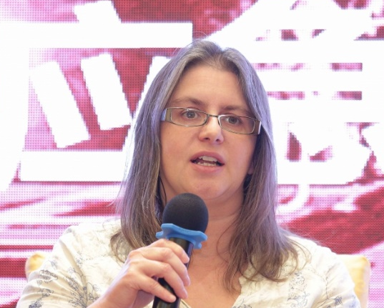

Dr Katherine Lamb is a respected authority on the training and assessment of incident command and crisis decision making. She received her MSc from the University of Oxford and her doctorate at the University of London. She worked as an accomplished researcher before joining the Fire Service in 2004. During her Fire Service career, she served in Birmingham, Manchester and Oxfordshire Fire & Rescue Services, where she held many operational roles, including Station Manager within the incident command training team.
In 2015, she established Effective Command, a charitable organisation which develops the concept of the thinking commander - someone who has the capacity to deal with the unexpected. This development tool is accredited by several professional bodies and academic institutions and is used to train and assess incident command competence and crisis decision making. It is widely used throughout the international emergency response community for the training of crisis decision makers.

